Salim Ghazi Saeedi’s Poetry Press Kit

Website: www.salimworld.com
Twitter: www.twitter.com/salimgs
Facebook: www.facebook.com/Salim.Ghazi.Saeedi
Blog: www.salimworld.com/blog/
Biography: See the last page.
Poetry Samples: 5 poems included here
More poetry: www.salimworld.com/word/poetry.htm

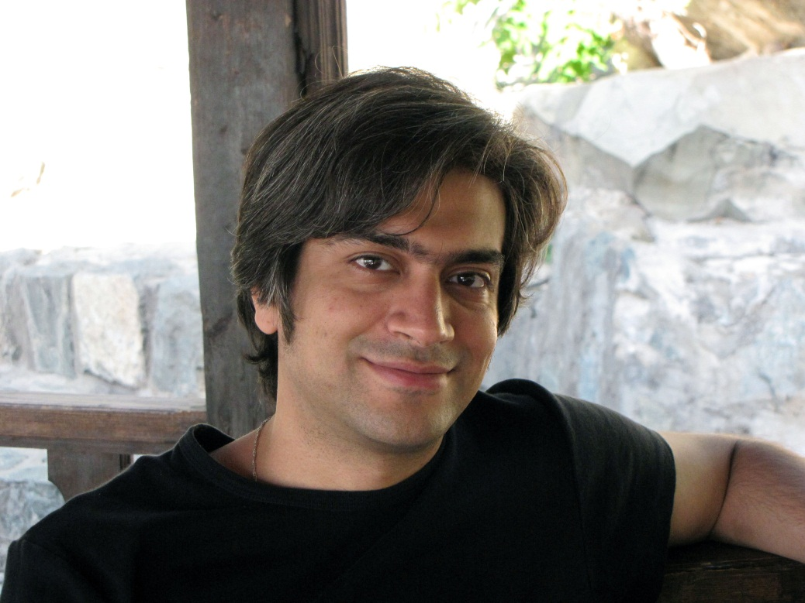
More photos: www.salimworld.com/pik.htm

Home
Of the world, let yourself out.
Of own world, let yourself out.
If you built today world, let it be and yourself out.

At home dwells death.

26 Sep 2011
Wanebook
Salim Ghazi Saeedi

Bitter n’ Dark
Bitter n’ dark...
Yea, silence runs in my mind...
I’m running in my mind’s silence.
Conceiving is an arbitrary act.
Conceive whether suffering or joy.
Pulling this lever and thoughts’ tracks switch.

Bitter n’ dark...
Switchmen live long.

2011
Wanebook
Salim Ghazi Saeedi

Flights
Run away!
Do not think that only vault needs escape.
Run away even from heavens no matter how big and appealing it is.
Refuse captivity!

2011
Wanebook
Salim Ghazi Saeedi

The King of Bads
In my state,
Goods slaughter bads.
And in my childhood dreams I have always been the king.
The king of bads.

2011
Wanebook
Salim Ghazi Saeedi

The word which dropped
I, Salim Ghazi Saeedi, the undersigned was a naked child,
who walked
and arrived here.

In the way, I saw no one.
At the river, I saw my face.
Then, with the moon I danced.
Slept one night
and woke up the day other:
I laughed.

And the death never beheld I.

24 July 2011
Wanebook
Salim Ghazi Saeedi

Biography
Salim Ghazi Saeedi was born in 1981 in Tehran, Iran. Among his family and relatives nobody were engaged in artistic career professionally and as a teenager he was mostly interested in electronics and computers. Besides, post-war limited artistic environment in Iran made him isolated from artistic currents. In puberty age he was more a rock music fanatic and in the realm of literature his main studies merely included Sadeq Hedayat and Jalal Al-e-Ahmad book series. As an engineering freshman in university he started self-teaching guitar and since 2006 he published 6 music album in avant-garde progressive rock as a composer in Arashk band and a one-band-band.
Salim says: "Generally I am not regarded a well-read person and do not even recall that have had the dream of becoming a writer. But I have always loved writing letters, reading well-known writers' letters and especially biographies." He continues: "One of my hobbies is making gifts for those I love and almost always I attach memos to them. After writing these memos I assume myself as their reader and read them repeatedly. I find this enjoyable a lot."
Salim began writing poetry at age 28 and wrote poem collections including Strings, Stuffings, Wanebook, The Book of Creator, Rest House, O Friend! originally in Farsi. He also undertakes translating and sometimes rewriting them into English himself. His poetry is mostly abstract/philosophical in atmosphere and is sometimes sermon-like. "But the matter of poetry without addressee is totally different. I nearly always write poetry only in moments of despair, fear or paralysis. These poems are actually addressed to myself and their goal is self-treatment. If you find me writing poetry you could be sure about two things: I feel very bad and I will get well very soon."
At age 31 Salim found himself writing short stories. Stories at the border of reality and fantasy with god-like protagonists: "There is a state that happens to me prior to creation of any artistic work. A state of readiness for creation. My mind enters a potent silence state and I realize something is going to happen. At this occasion if I pick the pen or instrument something will happen that I have no idea about before it ends. Maybe it could be said I divide and a part of me realizes in front of myself."
Salim's writings and compositions are accessible at www.salimworld.com

